Our first example of machine learning is making a genetic algorithm; the goal is to develop a little coloured person game that will breed new people colours based on your choice of the “fittest.” Let’s start by looking at the difference artificial intelligence and machine learning:

Artificial Intelligence encompasses a whole domain of intelligent and behavioural algorithms. You can see the types of things covered here. Machine Learning is a small area within that domain.

AI Domains

What is Machine Learning (ML)?

ML is a system that has the ability to automatically learn from experience and adapt in real time rather than being explicitly programmed to do so. Here you can see character attempting to learn to walk:



Source: https://rednuht.org/genetic_walkers/

We will talk more about him a little later, but for now it is important to note that it requires quite sophisticated mathematics and statistics. For our work, it is worth learning about quaternions. This is something you should define in your own words, so briefly stated:

Quaternions are effectively extensions of the complex numbers. Instead of just the square root of -1, there are three, called i, j, and k. Quaternions, therefore, consist of a real-part and three imaginary parts. When you multiply them out (*i.e.* i*j*k) the result is equal to -1. These rules are sufficient to derive the formula for quaternion multiplication, that should be noted, is non-commutative (*i.e.* there exist *a* and *b* in such that a*b and b*a are different). The *conjugate* of a quaternion has all the imaginary parts negated.

**More complex details that you can safely ignore… for now.**

The set of unit quaternions is a double cover for the set of 3D rotations, meaning for every rotation in 3D space, there are exactly 2 corresponding quaternions. Used in this way, the operation of quaternion multiplication is equivalent to the operation of composition of rotations.

Quaternions are preferable to Euler/Tait-Byran angles because they do not possess any singularities. With Euler angles, you sometimes get a situation where a continuous rotation of the object would cause an abrupt jump in one of the parameters. This situation is called gimbal lock, and it means more complex code is required to implement Euler angles properly. Quaternions are also much easier to interpolate and compose than Euler angles (Naive linear interpolation/composition of individual Euler angles will *not* work).

Quaternions are preferred over rotation matrices because they are much smaller, and composition is quicker. However, quaternions are slower at transforming vertices so they should be converted to a rotation matrix before passing to the vertex shader.

What Are Genetic Algorithms?

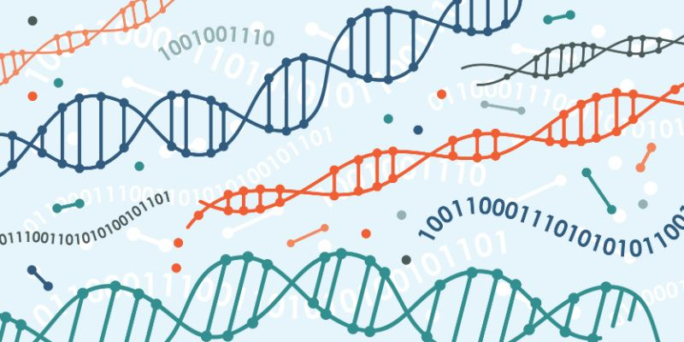

Genetic algorithms (GAs) are a type of computational optimisation technique inspired by the principles of natural selection and genetics. Simply put, we can call Gas “computational evolution.” They are used to solve complex problems by mimicking the process of evolution to improve a population of potential solutions iteratively.

As we will see in this Unity project, at the core of a genetic algorithm is the concept of a population, representing a collection of potential solutions to the problem at hand. Individuals within the population correspond to a particular solution, and a set of parameters called genes defines its characteristics. These genes encode the properties or features of the solution. While these features can be represented as binary strings (and often are), we will be working with real-valued numbers, and other data types as we code for a coloured person bias in a population.

The genetic algorithm begins with an initial population of individuals that we will generate randomly. We then go through a series of iterations, known as generations or epochs, in which the individuals undergo operations such as selection, crossover, and mutation. These operations mimic the processes of natural selection, reproduction, and genetic variation observed in biological evolution.

During the selection phase, individuals from the current population are evaluated based on a fitness function­—in our case, colour. The individuals with higher fitness values are more likely to be selected for further processing, simulating the survival of the fittest. Initially, these fitness values will depend upon the user’s bias as you select a colour from a set population.

**Genetic Algorithms Simply Put (Evolutionary Computing)**

1. A population of agents is programmed to randomly act.
2. The population acts.
3. The actions of individuals are assessed according to some fitness criteria and the unfit are culled.
4. The remaining individuals breed to create a new population.

Technical Details in GAs

**Recombination**

Crossover, or recombination, is a genetic operator where two selected individuals exchange genetic information to create offspring. This operation is analogous to sexual reproduction, where genetic material from both parents is combined to produce genetically diverse offspring.

**Mutation**

Mutation introduces small random changes in the genetic information of selected individuals. This operation helps maintain genetic diversity within the population, allowing exploration of different regions of the solution space.

**Generations**

After the genetic operators are applied, a new population is created, replacing the previous generation. This process is repeated for a fixed number of generations or until a termination condition is met, such as reaching a desired fitness level or exceeding a specified number of iterations.

Over the course of multiple generations, genetic algorithms explore the solution space, favouring solutions with higher fitness values. The algorithm can converge towards an optimal or near-optimal solution by iteratively applying selection, crossover, and mutation.

Genetic algorithms have been successfully applied to various optimisation problems, including parameter tuning, scheduling, routing, and machine learning. Their ability to explore large solution spaces and find globally optimal or near-optimal solutions makes them particularly useful in cases where traditional optimization methods may struggle due to complex or non-linear problem landscapes.

Let’s take a closer look at how this works in practice:



agent

Chromosome

Agent

DNA

Each agent has a string of DNA made up of chromosomes. Since we are programming our agent, we refer to this as an array with indices. We can place anything in the DNA array that makes sense with respect to its purpose. It could be a Boolean, int, float, *etc.* Let’s say this agent is in a maze-like setting.

Ceiling

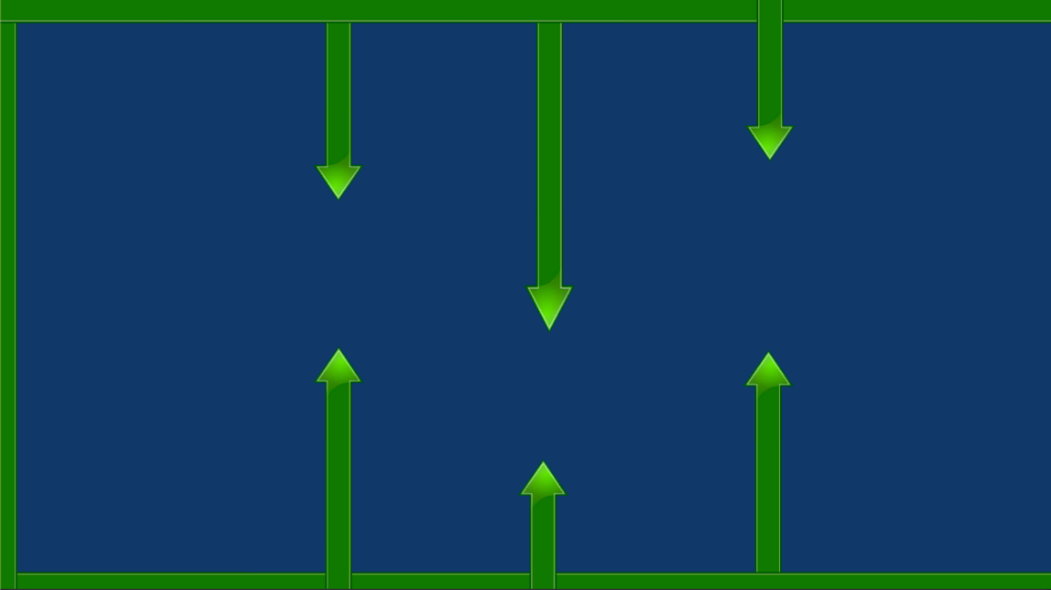

Bottom Arrow

Top Arrow

**Algorithm Simplified**

if (see ceiling)

move down

else if (see floor)

move up

else if (see top arrow)

move down

else if (see bottom arrow)

move up

Velocity



Floor

To simplify things, we have given this agent an automatic forward velocity that will push it forward. To get through this maze, the agent is going to have to move up and down. So how does it know when to do that? The agent needs some rules to follow! So we might hardcode these rules using ray-casts so when the rule it met, each of these “if conditions” becomes a chromosome in the DNA.

**Algorithm Simplified**

if (see ceiling)

move DNA[0]

else if (see floor)

move DNA[1]

else if (see top arrow)

move DNA[2]

else if (see bottom arrow)

move DNA[3]

else

move DNA[4]

Chromosome

Bottom

Nothing

Floor

Ceiling

Top

DNA

Now we can repeat the example with a population!

Nothing

Bottom

Top

Floor

Ceiling

DNA

Chromosome

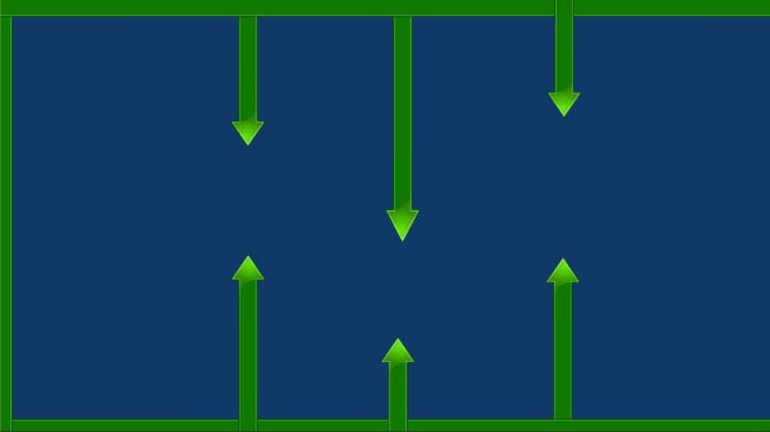

-0.2

0.1

-0.9

0.9

0.1

-0.2

0.1

0.9

-0.3

0.0

-0.5

0.2

0.3

-0.9

0.1



A whole population of our agents are set with random values of the chromosomes. Therefore, they can move in any direction at all when they detect any of the walls. Some lucky few will have chromosomes that help them move further across the screen. The further they get, the better their set of chromosomes. These are declared as the fittest, and the ones that did poorly are discarded. The remaining have their DNA combined to produce offspring. And the cycle iterates again. Notice we do not add the DNA values together but rather take some of the chromosomes from one parent and the rest from the other. This is the recombination.

So what about our character above learning to walk? After 3238 generations:



Now with some learning behind us, let us begin with our Unity project. First, create a new 2D project:

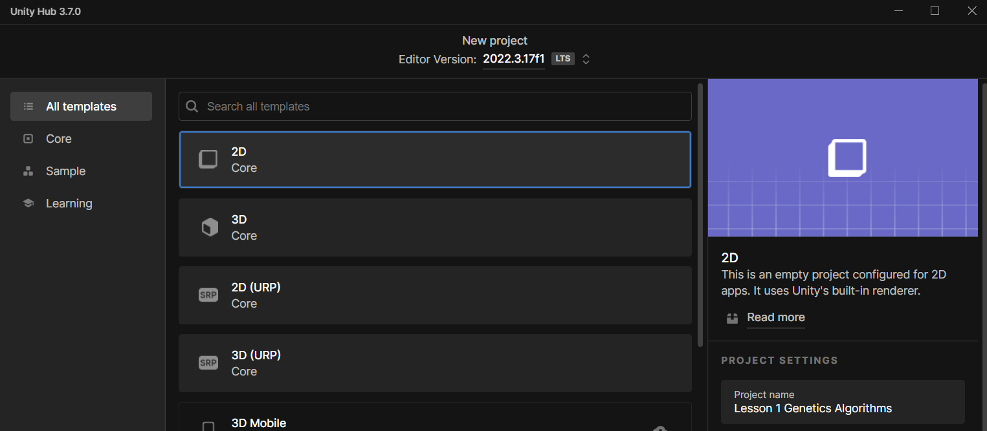

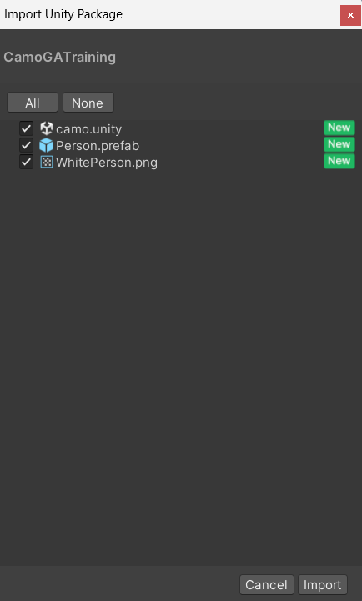Inside a folder named CamoGATraining (your teacher will give you access to this), with your Unity project open, open the file named CamoGATraining.unitypackage—this will bring up an import menu you can see to the left. Click import. From here, drag the file named “camo” into the scene (you can remove the default scene by right-clicking on the scene in the Hierarchy View > Remove Scene.

Also contained in the assets are the prefab Person (prefabs are generally indicated by a blue box), and a sprite named WhitePerson. The prefab Person contains a transform, a Sprite renderer, and a box collider (viewable from the Inspector panel).

The 2D Box Collider will allow us to click on the person prefabs (*i.e.* agents) triggering a destroy function. We will begin from here by creating a new C-sharp file. Right-click in Assets > Create > C# Script. Name the script DNA.

Before opening the script, drag and drop it onto the person prefab and make sure it is attached. Then you can double click on the script to open it in Visual Studio.

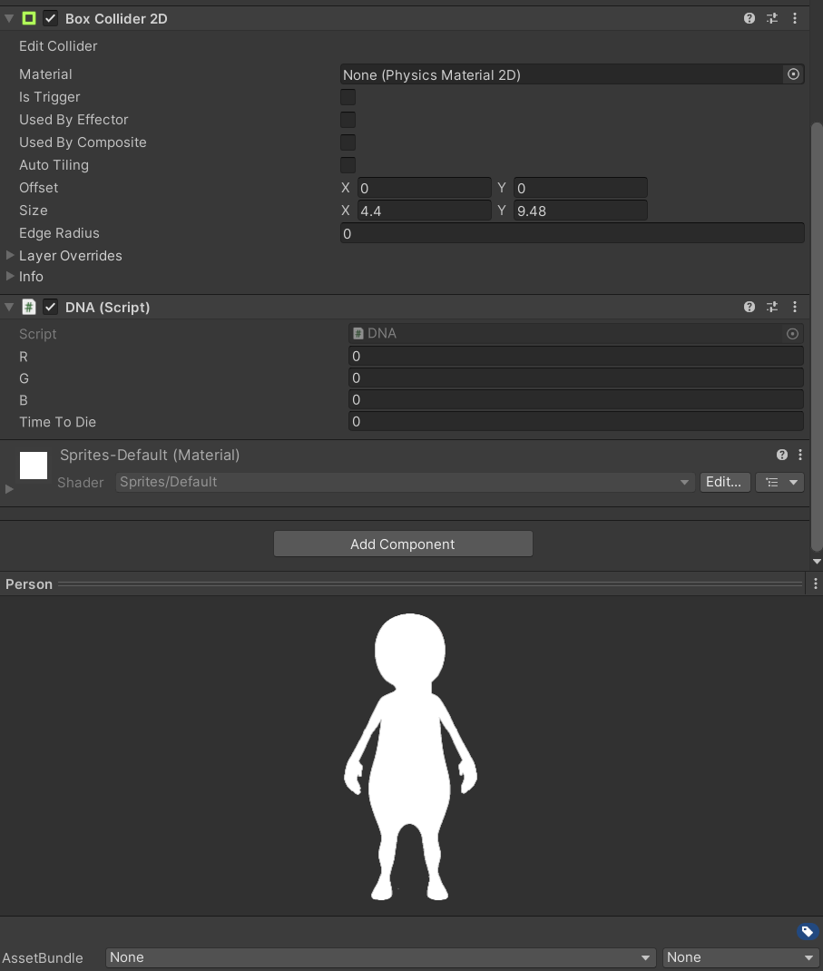

Casting our minds back to biology classes, remember that what we have is DNA and DNA is contained within a chromosome. It may make more sense to name this class Chromosome but, in any case, inside we have genes. And these genes responsible for passing along traits to our offspring. In this case, we want our people to pass values off to the offspring and that value will be associated with a colour, effectively passing off their colour to their offspring. So let us begin by storing the values for our people:

public float r;

public float g;

public float b;

Since we are only dealing with three values, we probably have no need for an array. So, we keep them stored as public float.

Now we need to store whether a person has been clicked so that when a player is clicked on, we will say they have basically died:

bool dead = false;

Now, every time we click on a little person, they will be destroyed and therefore, the ones that live the longest on the screen are going to be the fittest in this game. These will then breed with each other to form our new population. So, this boolean value will set to true after we have clicked on them.

Let us create the code to control the timeToDie.We will store this as a public float so that we can access it from outside the script.

public float timeToDie = 0;

When they do die, we will record how long they lived so that we can then later sort them according to their lifespan. Those that are the longest lived are considered the fittest, and we can then proceed to breed them. Before we program this, we need access to the Sprite Renderer and the Collider 2D:

SpriteRenderer sRenderer;

Collider2D sCollider;

Having access to the Collider2D allows us to interact with the people by clicking on them. We then want to initialise our renderer and our collider values to point to the SpriteRenderer and the Collider2D that are on our particular people. Next we’ll create a void OnMouseDown method—this is a simple way to create a mouse interaction which is a Unity owned method that you can use on a game object for detecting when something with a collider has been clicked, when the user clicks on the person, the person is destroyed and bool dead will become true.

void OnMouseDown()

{

dead = true;

timeToDie = PopulationManager.elapsed;

Debug.Log("Dead At: " + timeToDie);

sRenderer.enabled = false;

sCollider.enabled = false;

}

Next, timeToDie is going to be set to the time elapsed in our population manager that we will create shortly (ignore compiler errors since we have yet to create code that is referenced elsewhere). Finall, we have a line of code to check that our mouse clicks are registering:

Debug.Log("Dead At: " + timeToDie);

When you confirm the clicking works, you can comment this line out by using two forward slashes (// Comments follow double forward slashes). We have also disabled our sRenderer and sCollider by setting them to false. This will remove the Collider and will no longer allow to click on them since they are dead. Note that the GameObject will continue to exist in the hierarchy since we will need continued access to them (their genes specifically) so we can breed them. Thus, we turn them off rather than destroy them.

Next, we’re going to add an empty GameObject in the hierarchy:

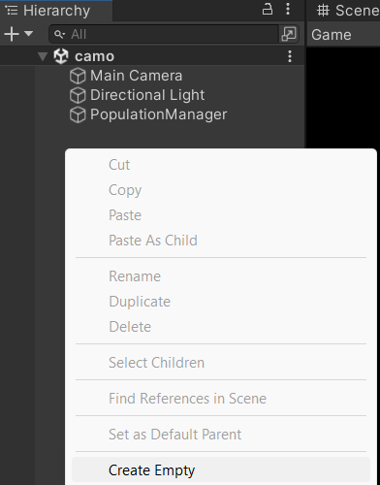

This GameObject is going to manage our population for us so rename it to PopulationManager. Create another C# script—we may not be able to add it to the PopulationManager GameObject since there are programming errors from the previous code. We will fix this with new code, so all we must ensure is we remember to add this script to the PoplulationManager before starting our project in Unity. Open up the PopulationManager script and create a link to our GameObject prefab within the public class PopulationManager:

public GameObject personPrefab;

Next we will set a reasonable population size (generally the bigger the better, but this is a clicking game—so set it to something reasonable):

public int populationSize = 10;

We also need to keep track of all the people that we create, so we can create a list to do this for us:

List<GameObject> population = new List<GameObject>();

public static float elapsed = 0;

Following the public static float elapsed our error will disappear allowing us to drag the C# script onto the PopulationManager. Next, we will initialise our game by creating 10 people inside the void Start():

for (int i = 0; i < populationSize; i++)

{

Vector3 pos = new Vector3(Random.Range(-7, 7), Random.Range(-3f, 3f), 0);

GameObject go = Instantiate(personPrefab, pos, Quaternion.identity);

go.GetComponent<DNA>().r = Random.Range(0.0f, 1.0f);

go.GetComponent<DNA>().g = Random.Range(0.0f, 1.0f);

go.GetComponent<DNA>().b = Random.Range(0.0f, 1.0f);

population.Add(go);

}

This for loop will loop around to a population size 10 times. Each time we loop, we will work out a random position on the screen to place our people. Since we are working in 2D we only need to set the X and Y values, so Z is made equal to 0. The range on the screen is from -7 to 7 in the X-direction and -3 to 3 in the Y-direction. This is based on my screen, you may need to figure out different values for your screen. To do this, you can grab one of our persons and place them in the scene in Unity. Then compare the Scene Tab and the Game Tab as you compare the X and Y values in the Position section under Transform. Once you have those values, simply plug them in!

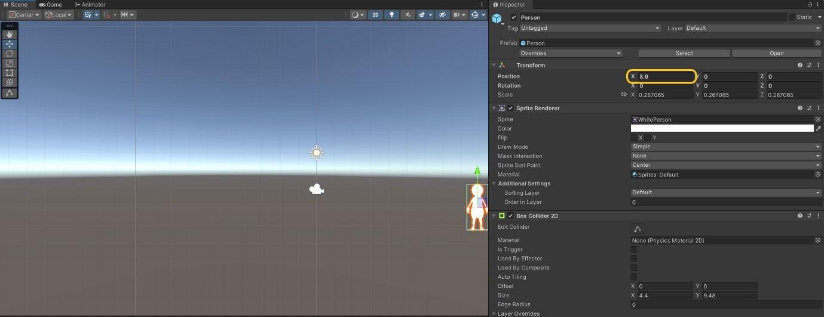

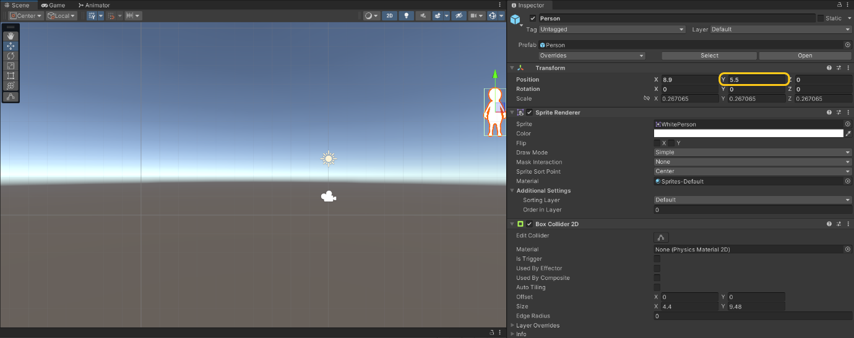

Now it is time to create our person!

GameObject go = Instantiate(personPrefab, pos, Quaternion.identity);

We create a GameObject and Instantiate it from the prefab at the position on the screen, and then we use a Quaternion to gives us a zero rotational value default. For now, we do not want any rotations in this case since we are just changing the position of that sprite on the screen in a 2D fashion.

Now we can go ahead and set their DNA. Remember that their DNA has a red, green and a blue channel, so we give them a random colour value, where 0 is none of that colour and 1 indicates all of that colour. Thus, when we have 1,1,1, we have white; 0,0,0 gives us black, and a mixture of those values will provide all the colours in between:

go.GetComponent<DNA>().r = Random.Range(0.0f, 1.0f);

go.GetComponent<DNA>().g = Random.Range(0.0f, 1.0f);

go.GetComponent<DNA>().b = Random.Range(0.0f, 1.0f);

Finally, we add that new GameObject we've created to the population list:

population.Add(go);

Let us take he time now to save our work! We can now go back into Unity and confirm our error we had before has disappeared. If you have not done so already, select your PopulationManager in the hierarchy and drag and drop our new script onto the inspector.

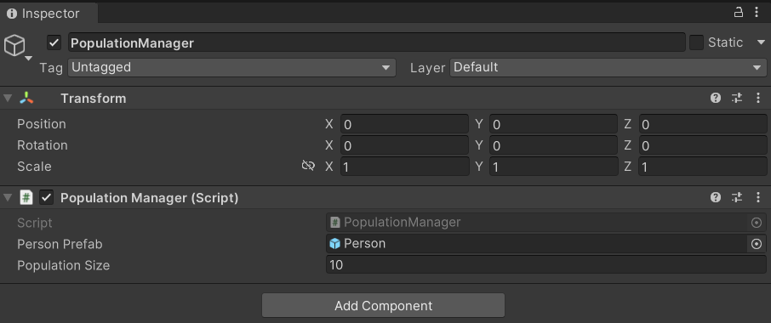

Also, for the person prefab that exists in the inspector, we can now drag our person prefab onto the Person Prefab under the Population Manager Script. Now press play and ensure everything is working as intended; we should see 10 people at random locations on the screen. They are currently all white since we need to the colour inside of the DNA script. In void Start() add the following:

sRenderer = GetComponent<SpriteRenderer>();

sCollider = GetComponent<Collider2D>();

sRenderer.color = new Color(r, b, g);

Switch back to Unity and confirm the previously white coloured sprites now have differing colours. We should also be able to click on them (since we have attached that script previously). Let us go back to our Population Manager and start adding in some code for breeding. Under public class PopulationManager add two integers:

int trialTime = 10;

int generation = 1;

The trialTime gives us 10 seconds to click ten people while our int generation will keep track of which generation we are currently in. Finally, let us create a way to display these bits of information on the screen:

Using the inbuilt Unity OnGUI():

GUIStyle guiStyle = new GUIStyle();

private void OnGUI()

{

guiStyle.fontSize = 31;

guiStyle.normal.textColor = Color.white;

GUI.Label(new Rect(7, 10, 100, 20), "Generation: " + generation, guiStyle);

GUI.Label(new Rect(7, 65, 100, 20), "Trial Time: " + (int)elapsed, guiStyle);

}

You may need to adjust the values slightly so they fit in with your screen. First we set up fontSize and textColor. Then we print out the Generation with whatever the current generation value is added to it. Finally, the Trial Time followed by whatever time elapsed will been added and displayed.

Next, we need to update our timer in void Update():

elapsed += Time.deltaTime;

if(elapsed > trialTime)

{

BreedNewPopulation();

elapsed = 0;

}

All that is happening here is, as our time value increases, our elapsed value plus the change in time (Time.deltaTime) will continue to keep adding the time between frames and output this value to our screen in seconds as the time elapses. Then, if the elapsed time has become greater than the trial time, the trial is over! We have therefore reached 10s.

In the next lesson we will create a new method called void BreedNewPopulation() to find out which of our people that have been created are the fittest—and we will breed them together.